|  |
| --- |
| User Manual  Samuda Inventory |
| REFERENCE: GW/ERP/USER MANUAL |
|  |
| **Genweb2 Ltd.** |
| **11-Apr-18** |



|  |
| --- |
|  |

# Document Information

|  |  |
| --- | --- |
| Document Name | User manual for Inventory |
| Document Author | Rashedul Alam |
| Document Version | 1.0 |
| Release Date | 11th t April, 2018 |

|  |  |
| --- | --- |
| Review by | Md. Matiar Rahman |
| Review Date | 12th April, 2018 |
| Approved By |  |
| Approval Date |  |

# Document History

|  |  |  |  |  |  |
| --- | --- | --- | --- | --- | --- |
| A=Added, M=Modified, D=Delete | | | | | |
| **Version No** | **Date** | **Section No** | **A/M/D** | **Description of Change** | **Author** |
| 1.0 | 11-April-2017 |  | A | Initial | Rashedul Alam |
| 1.1 |  |  | A |  |  |
|  |  |  |  |  |  |

Contents

A. Document Information 2

B. Document History 2

1. Introduction 4

1.1 Purpose of User manual 4

2. Configuration by Inventory Manager 4

2.1 Create Indent type by Inventory Manager 4

3. Indents 5

3.1 Create Indent by General/Indent Manger user 5

4. Indents approval by Department Manager 6

4.1 Indents approval by Department manager 6

5. Issue PR 8

5.1 Create Issue PR by Inventory user or Manager 8

6. Issue PR approval by Head of Account 9

6.1 Issue PR approval by Head of Account 9

7. Gate in 12

7.1 Create Gate in by Gate in Approver 12

# 

# 1. **Introduction**

The purposes of this User manual is to clearly identify the customer requirements and provide a detailed document. The customer will read this document and get a clear view the sales module. It will also help the review team to validate whether the customer requirements have been fulfilled or not.

## Purpose of User manual

The purpose of this User Manual is to clearly identify the customer requirements and provide a detailed document. The customer will read this document and get a clear view of the Commercial module. It will also help the review team to validate whether the customer requirements have been fulfilled or not.

# 2. Configuration by Inventory Manager

Some configuration require for Inventory module, Admin user can configure this.

## 2.1 Create Indent type by Inventory Manager

Indent type is require for indent creation.

Inventory Manager can create Indent type using the menu **Inventory ‣ Products ‣ Indent type** and click **Create.**

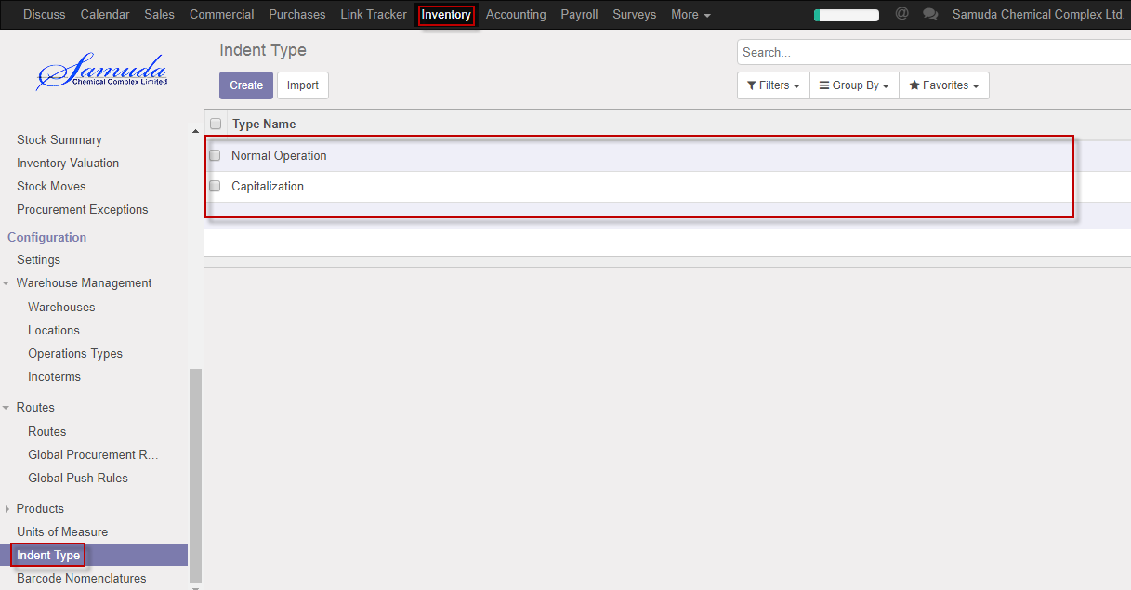

Figure: Indent type List view

We need to set the following:-

**Type name**: Enter a type name.

**A**fter entering all information click **Save**.

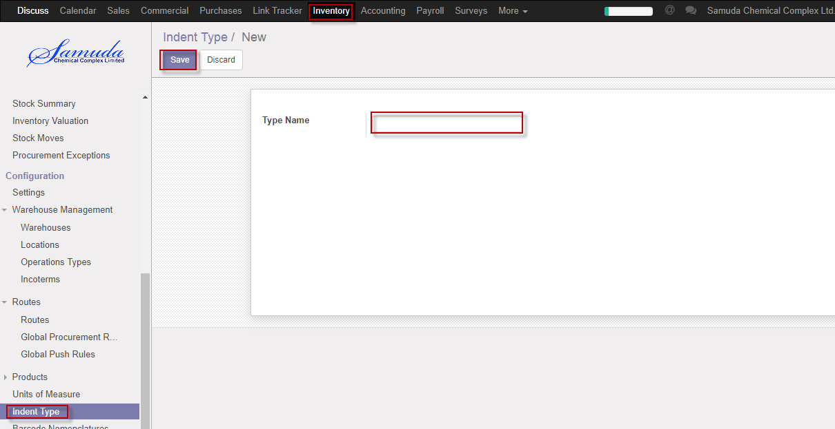

Figure: Create a Indent type

# 3. Indents

## 3.1 Create Indent by General/Indent Manger user

Indent will be created/Edit by General/Indent manager

Indent manager can create Indent using the menu **Inventory ‣ indents** and click **Create.**

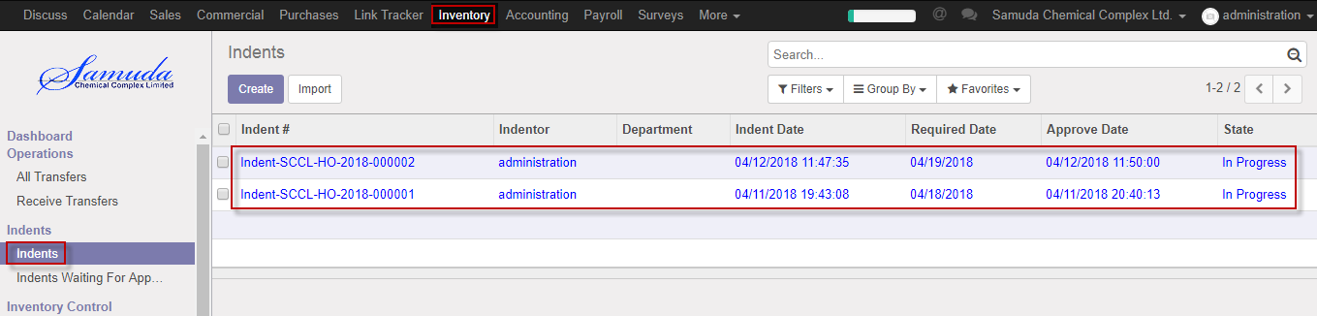

Figure: Indents List view

We need to set the following:-

**Priority**: Select priority.

**Required date:** Select required date.

**Type:** Select type.

**Product:** Select product.

**Quantity:** Select qty.

After entering all information click **Save & Confirm**.

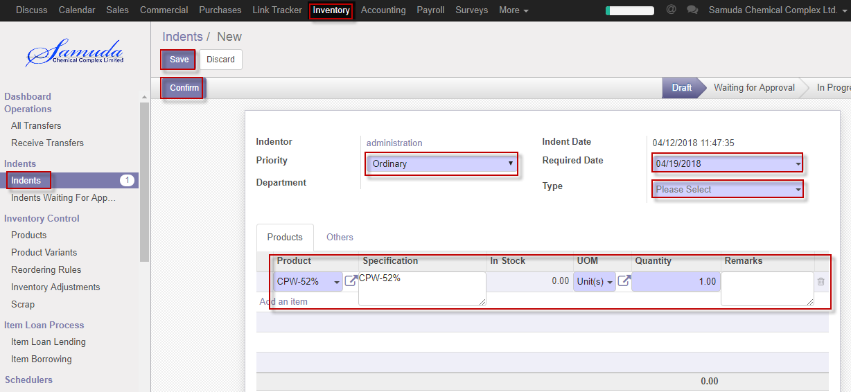

Figure: Create Indents

# 4. Indents approval by Department Manager

Head of sales will approve first approval. If unit price & commission no change then it will done state.

## 4.1 Indents approval by Department manager

After apply the Indents Department manager will get the notification. He/she can update before approve if require.

To see the Pending indents use the menu **Inventory ‣ Indents>>Indents waiting for approval**

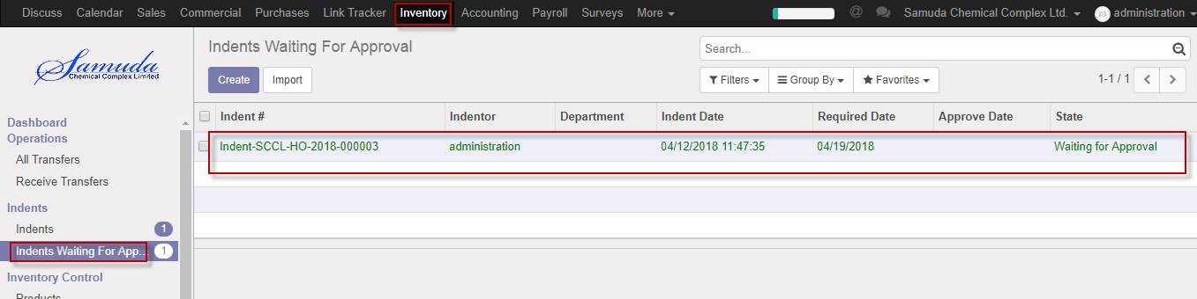

Figure: Indents waiting for approval list view

Department Manager can approve. Select an indent from list then click on **Approve** button 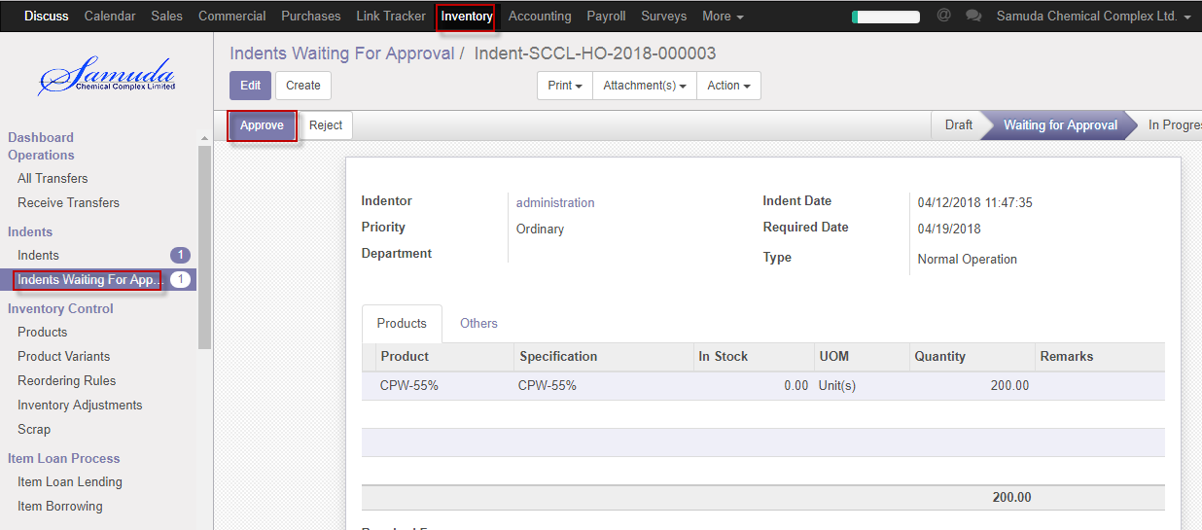

Figure: Indents approved

Department manager is capable to reject indent by click **Reject** Button.

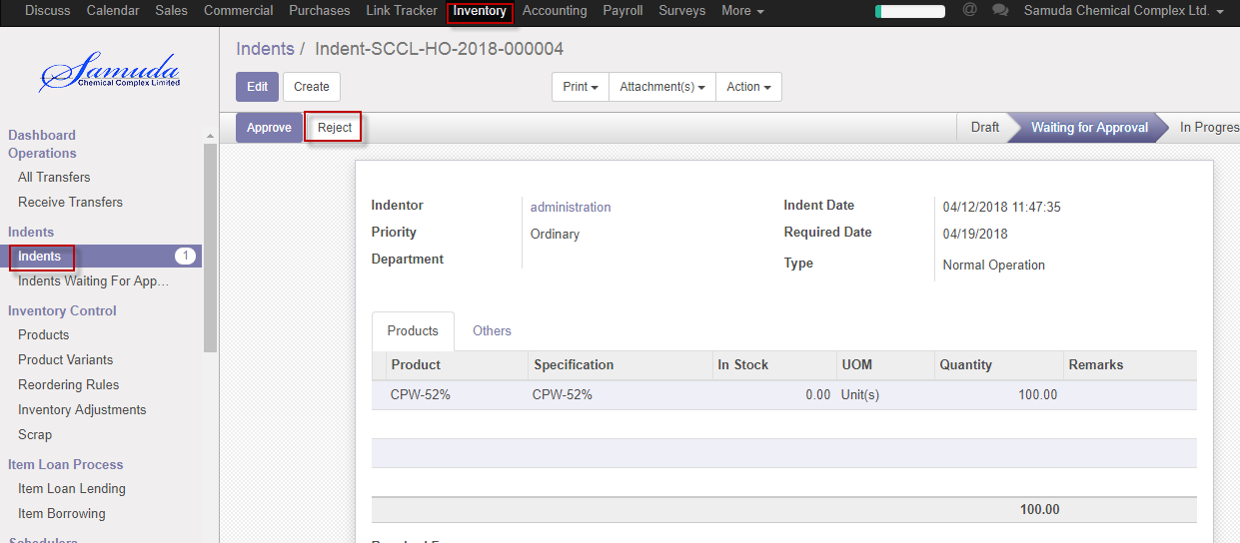

Figure: Indents reject

# 5. Issue PR

## 5.1 Create Issue PR by Inventory user or Manager

Indent will be created/Edit by Inventory user/Manager.

Inventory manager/user can create Issue PR using the menu **Inventory ‣ indents** >>**Issue PR and click & Confirm.**

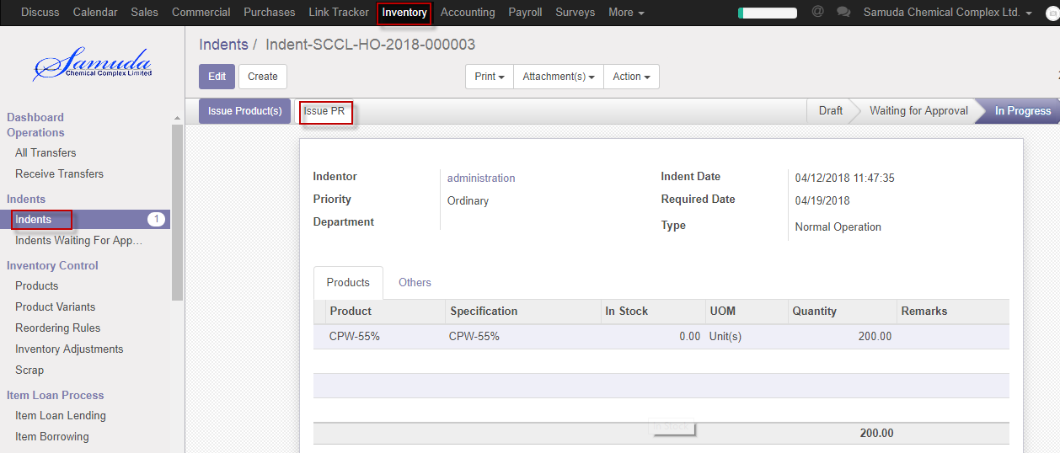

Figure: Create Issue PR

Validate Issue PR by click **Validate** Button. Validate by Plant in charge.

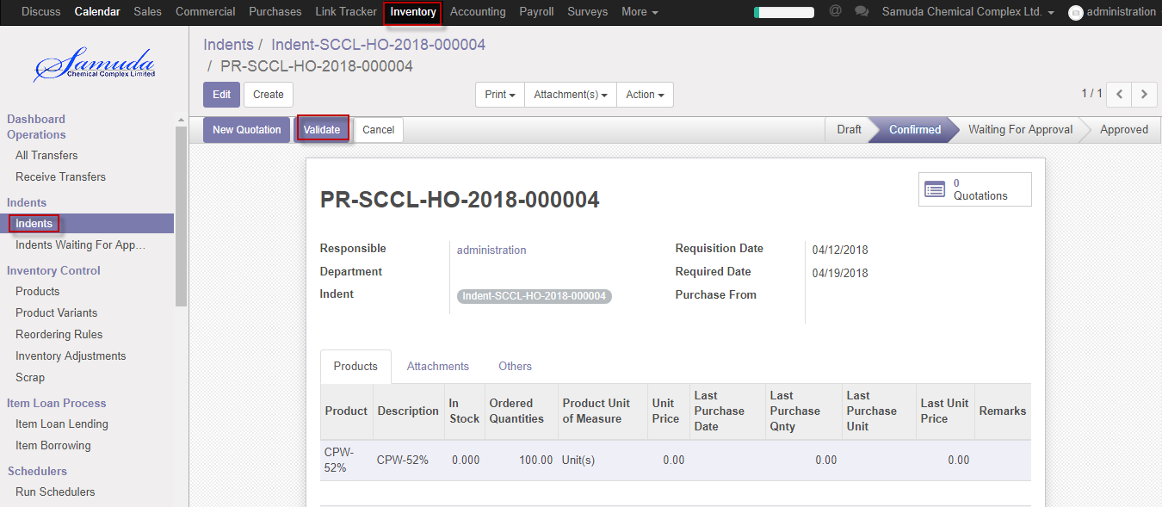

Figure: Issue PR validate

After click Validate button will open following window then Select purchase from & **Save**

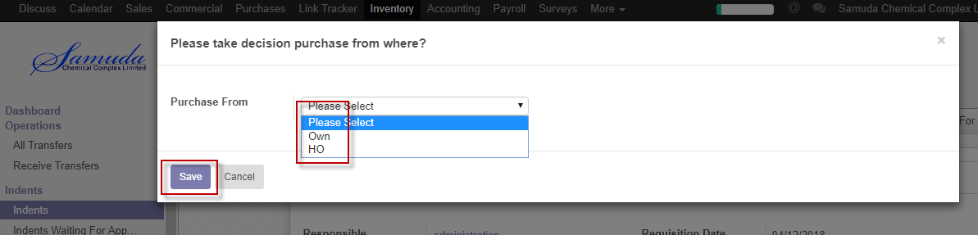

Figure: Create Indents

# 6. Issue PR approval by Head of Account

## 6.1 Issue PR approval by Head of Account

After Validate the Issue PR Head of Account will get the notification. He/she can approve to see use the menu **Inventory ‣ Indents>>Click Approve**

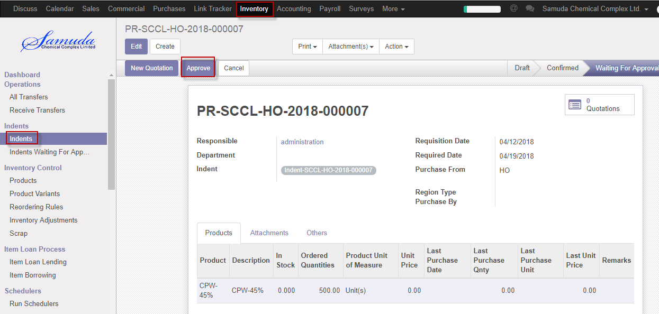

Figure: Indents waiting for approval list view

Following window will open after click **Approve** button then select region type & Purchase by 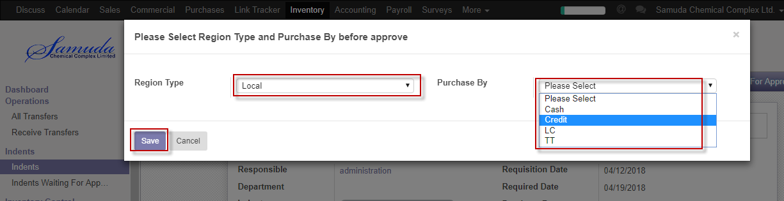

Figure: Before PR approval

Following window will open after click **save** button then will ready for New Quotation .New quotation Approve by Head of procurement.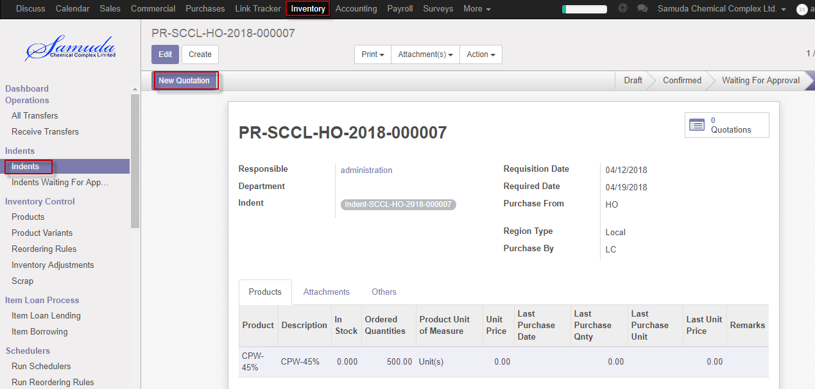

Figure: Create new quotation

Click New quotation button & Select supplier after select all info will come auto then Click **Confirm order** button. Confirmed By Head of Procurement.

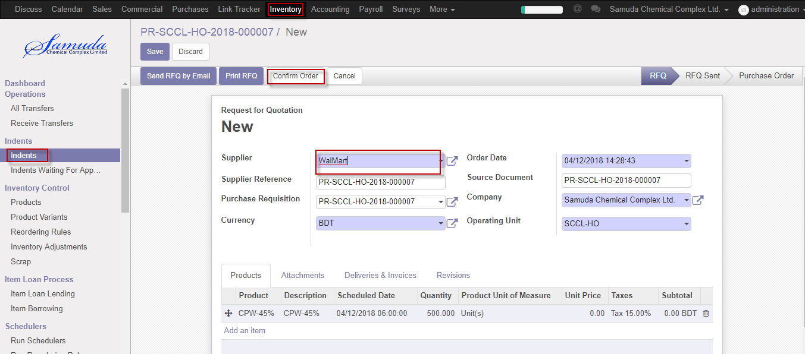

Figure: Confirm order

Following window will open after click Confirm order Button then select region type & purchase by then save then Click Purchase order button then finally Issue PR will approve.

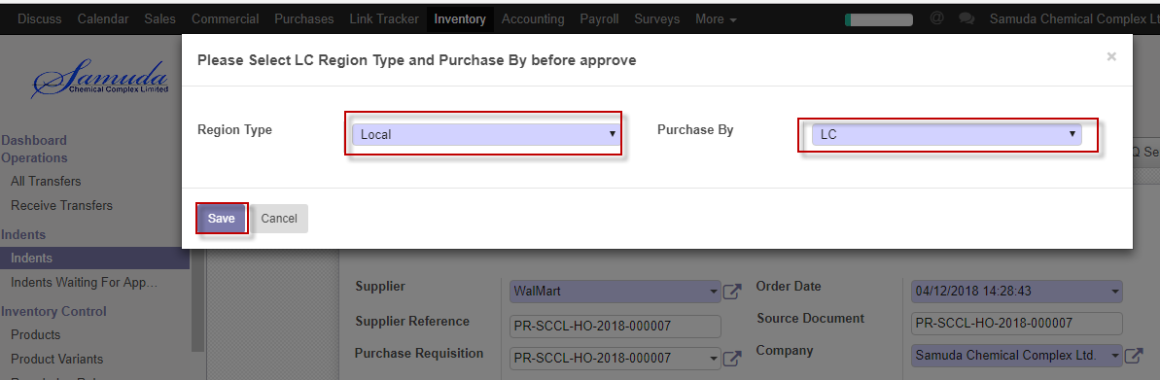

Figure: Before approve

# 7. Gate in

## 7.1 Create Gate in by Gate in Approver

Gate in will be created/Edit by Gate in approver

Gate in Approver can create Gate in using the menu **Inventory ‣ Product Gate in>>Gate in** and click **Create.**

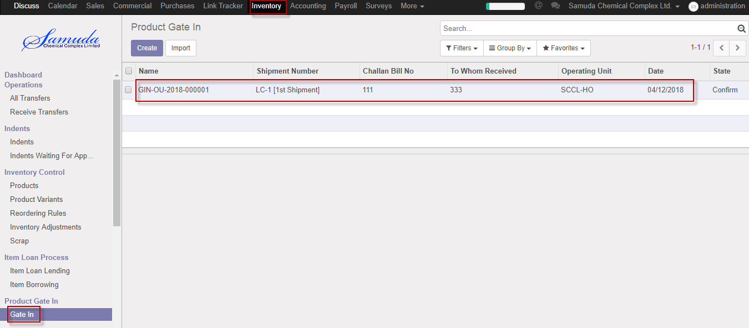

Figure: Gate in List view

We need to set the following:-

**Receive type**: Select receive type.

**Date:** Select date.

**Challan bill no:** Enter challan bill no.

**Track/Vehicle no:** Enter Track/Vehicle no.

**Shipment No:** Select Shipment no.

**Carried By:** Enter carried by.

**To whom received:** Enter to whom received

After entering all information click **Save & Confirm**.

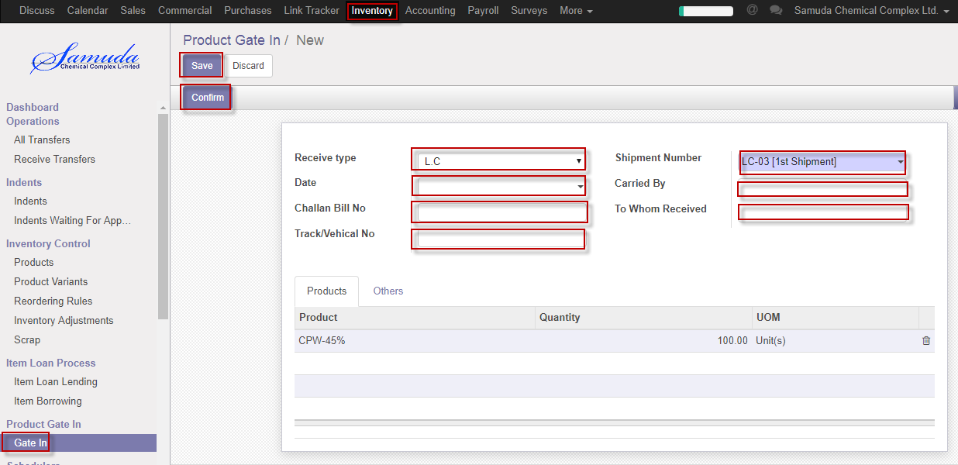

Figure: Create Gate in